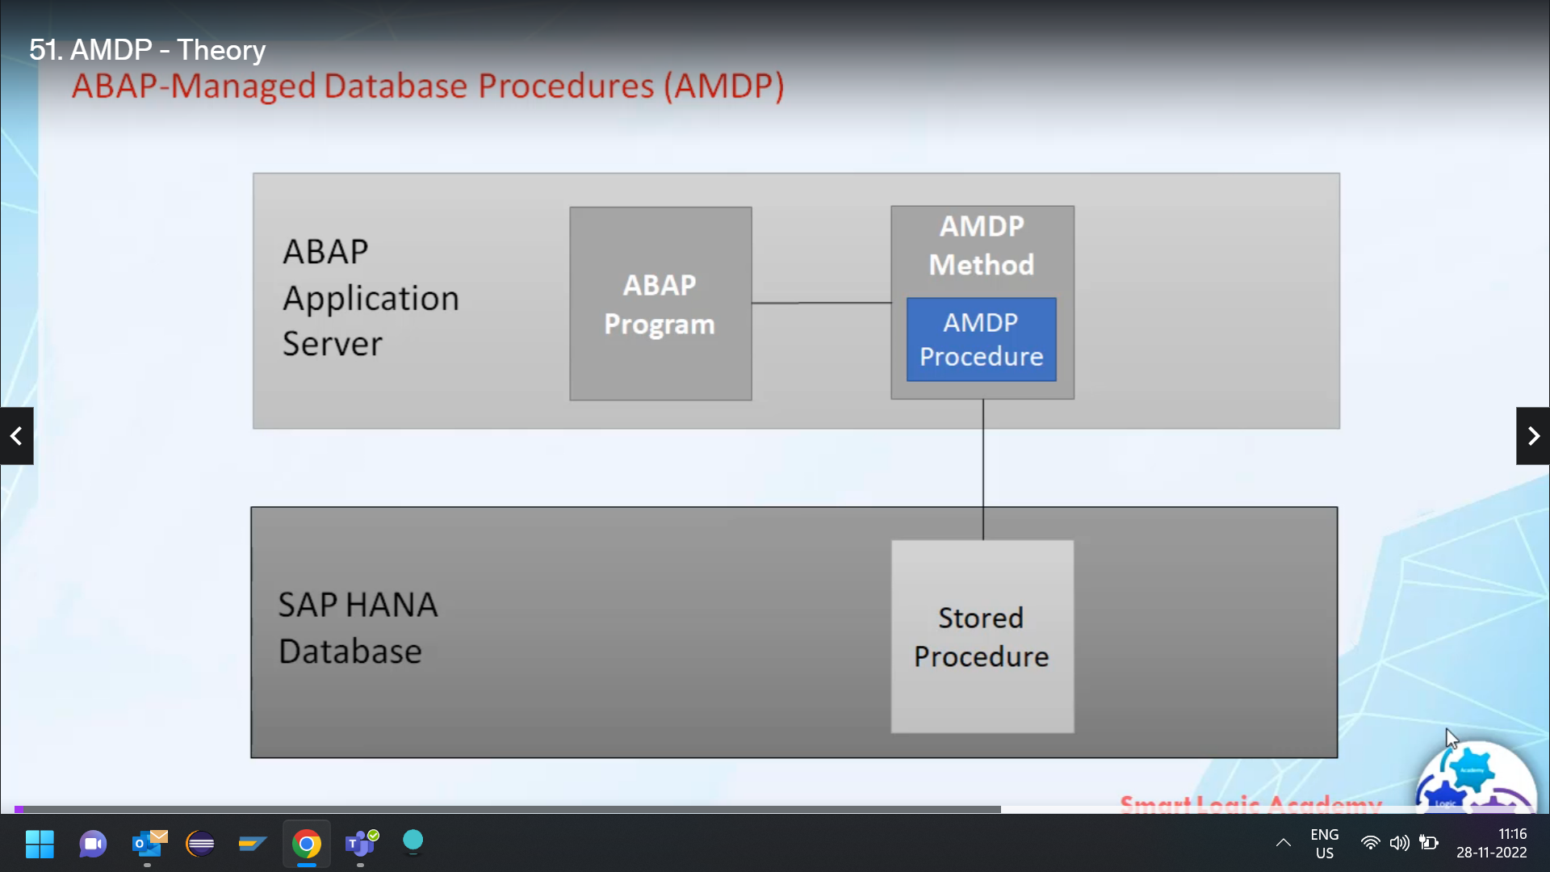

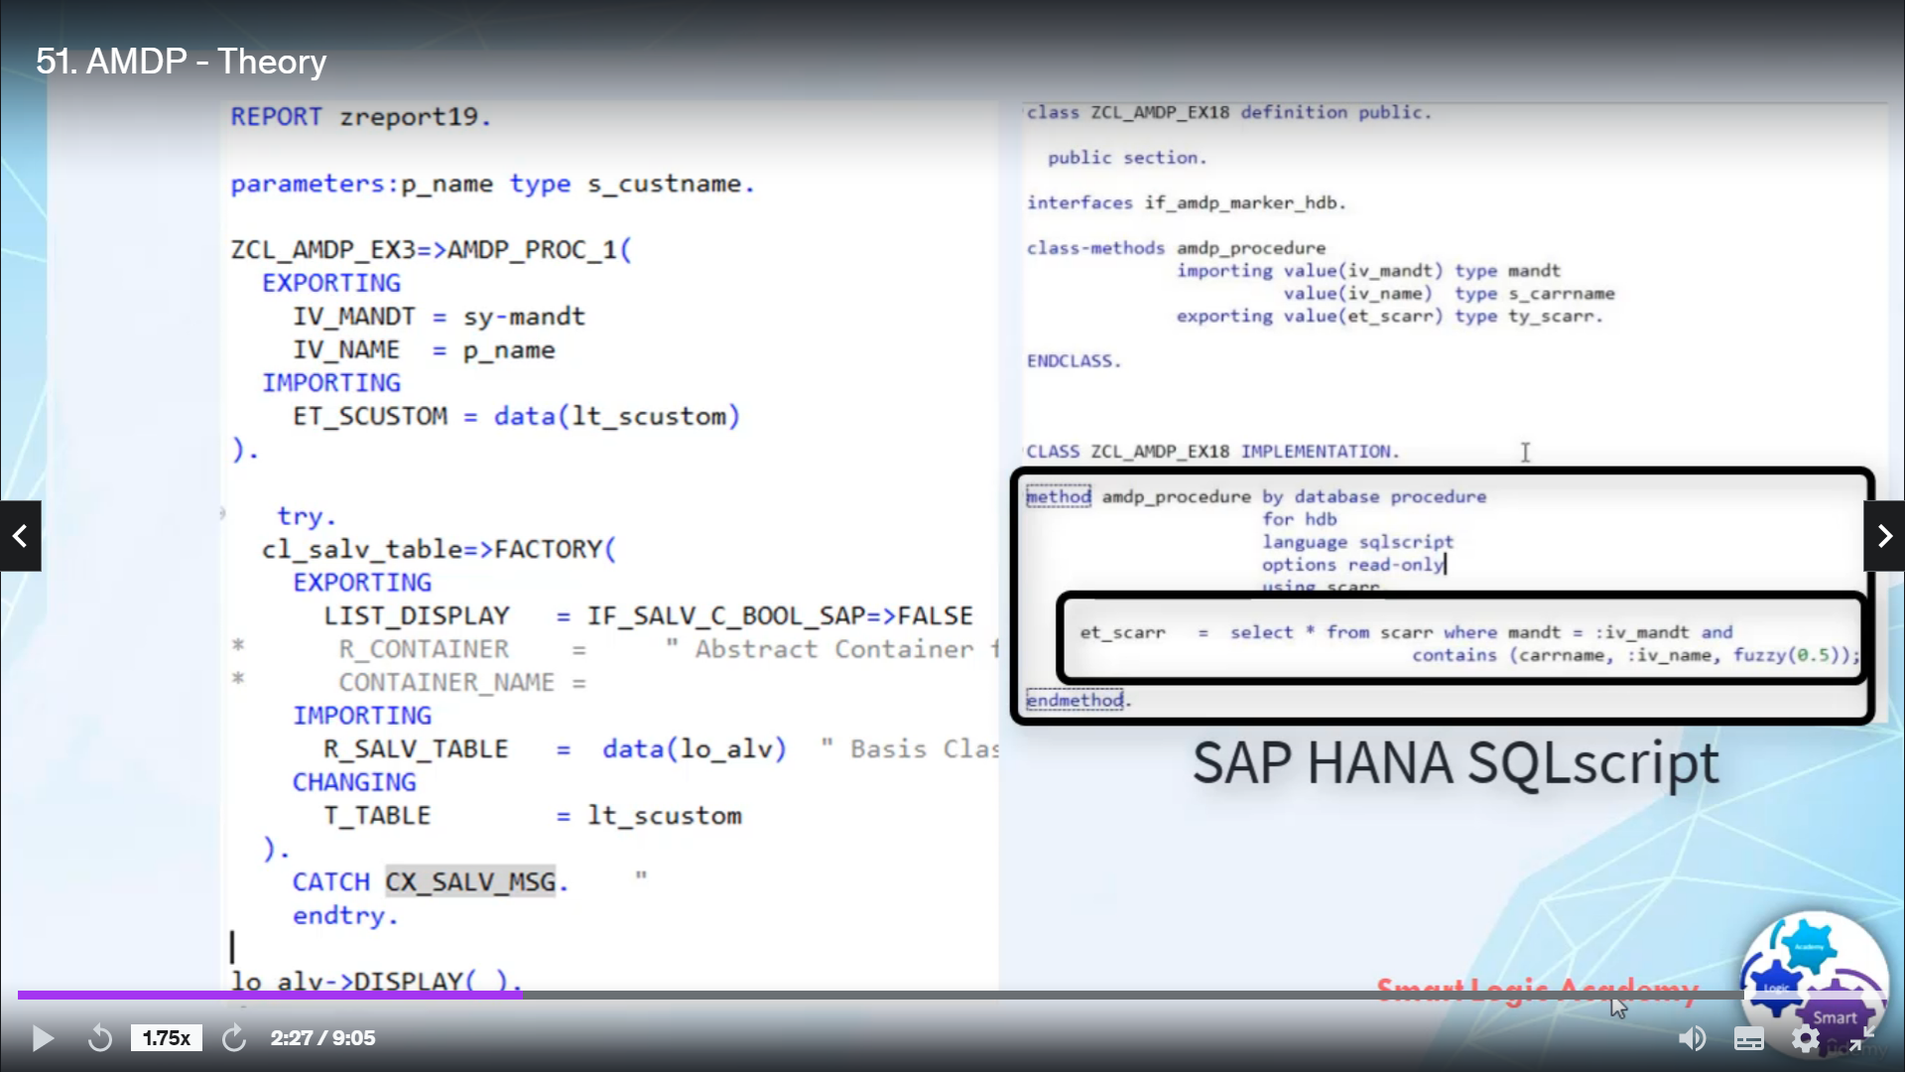

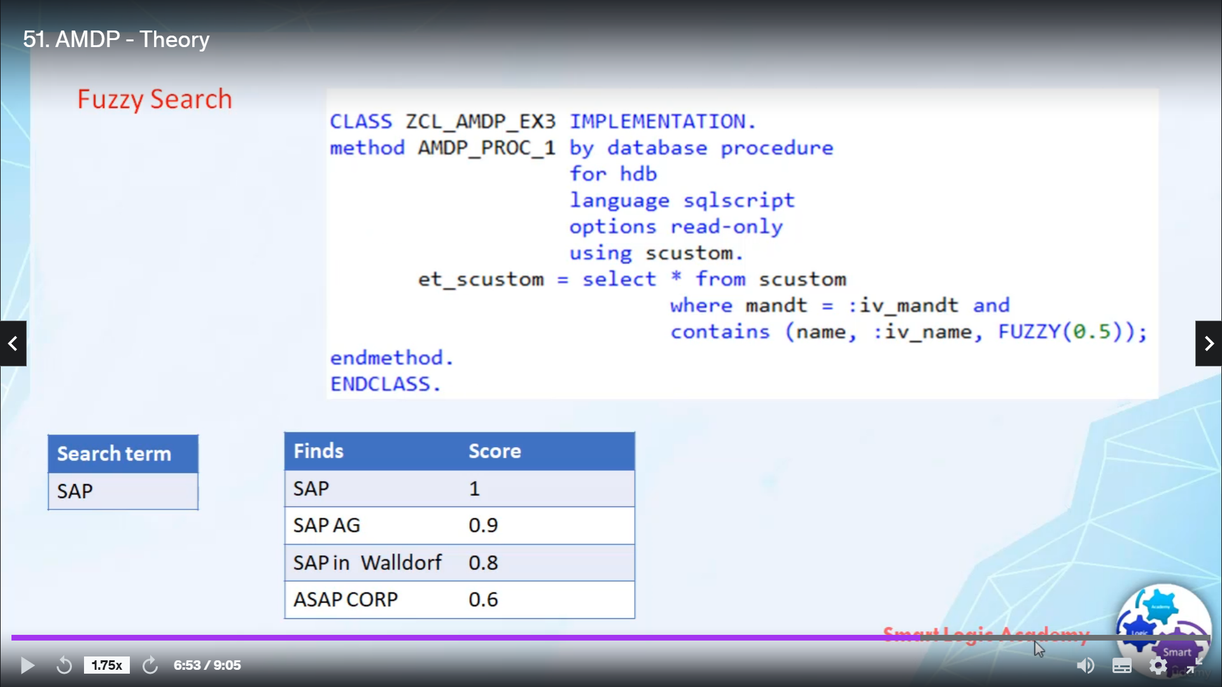

In this video, I will tell you about IMDB, I bet, manage database procedures.

I will explain all the necessary theory related to IMDB, such as what is IMDB, what is deep matter,

what is MGP class and so on.

So let's start.

Almost every day, support database procedures, search procedures are stored and executed on database.

The implementation is usually written in the scripting language that is highly specific.

As of release, seven one four zero zero five.

Abbott supports database procedures that are stored in Abbott proposed and transported with standard

Abbott transport requests.

This technique is known as have managed database procedures.

It simply offers the best procedures as top down approach to create and call store procedures on a behind

database.

Using new MGP technique editing, Activision, transport and lifecycle management of database procedures

are performed on a Web application server.

The database procedure is defined and implemented as a matter of global class, the implementation of

such a method consists of database specific script that can only be executed on database, but not on

a website.

The NDP framework clears ASTORE procedures on the database and do that any calls to the NDP matter to

these stored procedures?

I bet many database procedures are created as methods of Abdulaziz.

But in contrast to normal methods, they are not implemented with absolute code, but with the database

specific programming language, such as is it Rihanna?

S script?

Whether a method is implemented in ABAB or any other language is specified with addition by database

procedure in metal implementation part.

For specifies the database on which the MVP can run here in this example, HDB stands for a safety database.

This is currently the only supported value.

Language specified the language of implementation here in this example, it is a school script.

This is currently the only venue available.

Using is required if metal implementation uses objects from above, additionally, transparent tables

and the display reviews are supported you.

CDU names are not supported here, if you want to use Syriza in HDP, then you have to accept corresponding

Soudas a school view.

Options, this one is intended for additional settings currently read only the only supported option.

The class definition part has to fulfill some prerequisite before the matter can be used as an imprimatur.

And let's see, what are these prerequisites?

Classes that are actas container for DP, how to implement interface aimed markhor HDB in the definition

of MGP class implementation of the interface MLP marker HDB is mainly aimed.

UPM parameters are allowed to be import export or changing parameters.

Retaining parameter cannot be used here.

The parameters of the permit would have to be passed by value and barometer types need to be eliminated,

type or tabletop structure type are not allowed here for parameters of table types.

The line item has to consist of elementary component because Mr. Tables are not supported as well as

I wish to restructure.

Types are also not supported.

In the perimeters can be defined in public, protected or private feasibilities sections of the class,

other classes can contain a mixture of Abbett methods and methods and methods are defined as static

methods, although you can define the perimeter as the instance methods.

But they are always executed like static methods.

It is mandatory to use about development tool to edit Amed methods.

The classical workbench only supports a display of database procedures.

Here are some advantages of using above tool for MGP.

ADT supports semantical completion for either part in MDT, you can check syntax of a code and it also

supports debugging of the perimeters.

Independently scored like any other ATM, MGP meters are executed like Startrek meters, even if they

are definers instance, Metal Vaina and BP's processed.

The Abbott government calls the corresponding database procedure in S.P.C.A..

I have covered all the territory to IMDB.

Now, quickly, I will add one more topic for the search, I want to cover this topic here because we

will use for this search feature of a city, Hannah, while writing in the procedure.

So let's quickly see what is for dessert.

For research, it's fast and for tolerance search feature of a Hannah.

A body search returns records even if the search team contains additional or missing characters or other

types of spelling errors.

For this to work on any column for tax index has been generated.

You can call for this by using function content, wait for the option in there because of the statement.

Contains Unfussy, buta FCP specific functions, and these functions are not available in open screen

or serious digital.

For definition has many parameters that you say to influence and fine tune the fuzzy search.

The most important parameter is fuzzy, trishaw.

This is a number between zero and one determines the degree of closeness between search term and distance

from.

Higher this cause, the more stimulus strings are.

A score one point zero means strings are identical.

And scored zero point zero means strings have nothing in common.

If you don't specify a threshold, then by default, zero point eight is used as a threshold.

That's it for now.

I hope you understood the theory.

Have a nice day.